Joan Stanford Chase
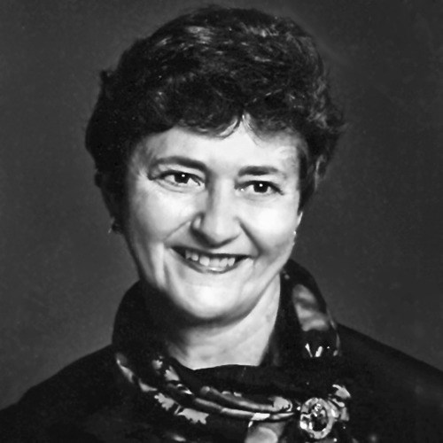
Joan Stanford Chase died surrounded by her beloved family on December 31, 2023, in Springfield, VA, from complications of aphasia. Born in Boston in 1938 to John and Alice Stanford, Joan spent her childhood moving to different Northeast cities. At age 13, she met the love of her life, Bob Chase, a classmate in her junior high school in Springfield, MA. She and Bob continued a long-distance relationship after her family moved to Portland, ME for her last two high school years. Upon graduating from Lasell College in Newton, MA, she moved to Hartford, CT and spent many weekends visiting Bob at Wesleyan University. They married in June 1959. After a year in Syracuse, NY, they moved to Fairlington, VA, and then to the Hollin Hills, VA neighborhood, where they raised their two children.
In 1982, Joan and Bob moved overseas, living in Morocco, Sri Lanka, and Rome and visiting more than 50 countries. As part of the official USAID and UN World Food Program communities, Joan was a vibrant informal ambassador for the US, cultivating warmth and friendships across the world. In Morocco she was one of the early foreign service spouses appointed as a Family/Community Liaison Officer and played a key part in designing that role. Returning to Washington in 1992, Joan became involved with the Women's National Democratic Club and shortly thereafter was elected its President. From that engagement with influential Democratic women, Joan volunteered for Hillary Clinton in the First Lady's public relations office. She also was deeply engaged with the intercultural women's group, Welcome to Washington, serving as President there as well.
Joan loved nature, music, design and color (especially blue), cooking and entertaining, sports, bridge, all-manner of word games, travel, her summer home in Maine, and engaging with new cultures. Above all she loved her family. She was quick to make friends and had a gift for making people feel comfortable and appreciated. Her vitality, constant smile and contagious warmth were borne of a worldview that all people are basically good, and that all problems are fundamentally manageable.
Joan leaves behind her husband of 64 years, Robert Carroll Chase; her daughter Linda Beth Sheriff (Jack Sheriff) of Arlington, VA; her son, Robert Stanford Chase (Genevieve Drewes) of Takoma Park, MD; and four grandchildren, Peter and Libby Sheriff, and Annabelle and Robert B Chase. She will be sorely missed by her two siblings, Carole Davis of Kennewick, WA, and David Stanford (Carolyn) of Vienna, VA; her brother-in-law, Ted Chase (Bobbie) and numerous nieces and nephews.
A Celebration of Life will be held sometime in the weeks ahead with details on the following website (https://obituaries.virginiacremate.com/obituaries/11561067); in lieu of flowers, consider a donation to World Learning (https://www.worldlearning.org/) or the National Aphasia Association (https://aphasia.org/).
Published by The Washington Post on Jan. 7, 2024.

